**Adventure works sales Report**

1.Yearly Sales Trend Analysis: Analyze the total sales trend over the years and identify any significant growth or decline in sales.

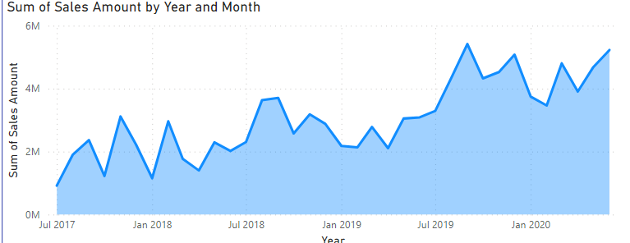

**Insights**: with reference to the chart, the major decline of sales occurred on January 2018 and the highest amount of sales occurred in September 2019.

2. Product Performance: Identify the top 5 performing products based on total sales and analyze their monthly sales trend for the last year.

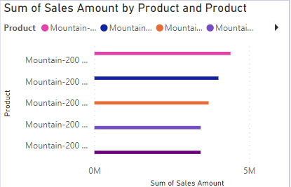

Insights: top 5 products are-

1. Mountain 200, black ,38
2. Mountain 200, black ,42
3. Mountain 200, silver ,38
4. Mountain 200, silver ,42
5. Mountain 200, silver ,46

3.Sales by Region: Compare total sales by geographical regions and highlight the best and worst performing regions.

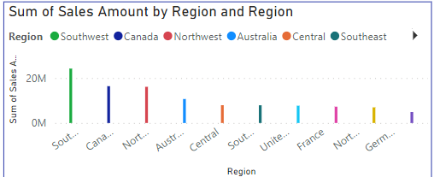

Insights: With reference to the visual, Southeast is the best performing region and Germany is the worst performing region.

4. Sales Channel Efficiency: Compare the efficiency of different sales channels (online vs. retail).

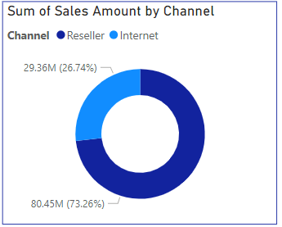

Insights: With reference to the visual ,Reseller channel is more efficient than internet.

5.Cumulative Sales Analysis: a. Create a DAX measure to calculate cumulative sales over a year. Use a variable to store the maximum date selected by the user and calculate sales up to that date.

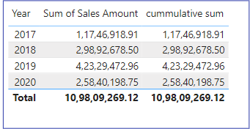

1. Year-over-Year Growth Percentage: a. Create a DAX measure that calculates the Year-over-Year growth percentage for total sales. Use a date slicer to let users dynamically select the year and visualize the growth trend.

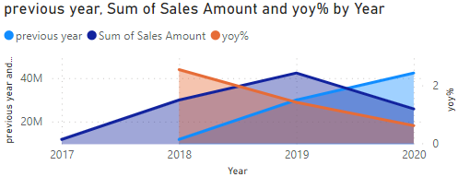

Insights: In 2018, the year over year growth percentage(yoy %) was 2.54 as the sales of 2017 was less than sales of 2018. In 2019, yoy% was 1.42 as the sales done in 2019 is less than sales done in 2018. Then , in 2020 yoy% was 0.61 as the sales done in 2020 is less than sales done in 2019.